**PLAN**

**What is needed:**

* Contact information
* Contactor information
* Patient’s information (name, phone number)
* Worker’s information (name, phone number)
* Advice (Given or taken)

**GDPR:**

* Data Minimisation (Only take information you need) I need to make sure that I only take information that is vital to be able to complete the job
* Storage limitation (Once a patient has left) I must create a way to remove information on patients once they have stopped using the service
* Transparency (Patients must be able to view their info) I must create a view or query where the user (patient or carer) can view the information we have on them

**Isolation:**

* They should have more than one contact to be able to call.
* Patients need a way to be able to get the information of their contacts

**IT Literacy:**

* Have queries have simple titles that are easy to understand
* Titles in the queries should be simplified and not be in camel casing so it is easier to read

**Queries (Plan):**

* Patients Contacts (Patient, Phone number, Contact Name)
* Carer’s Patients. Get all patients who are cared by ______. (Patient’s name)
* Which patients were contacted on behalf of someone else (patient’s name, contact name, contact phone number)
* Patient information (Be able to get a person’s information in one query of the patient wants access to their data)

**Roles:**

* Career or patient (be able to view all patient data)
* Worker (view and make changes to

**Security**

* Backup the database

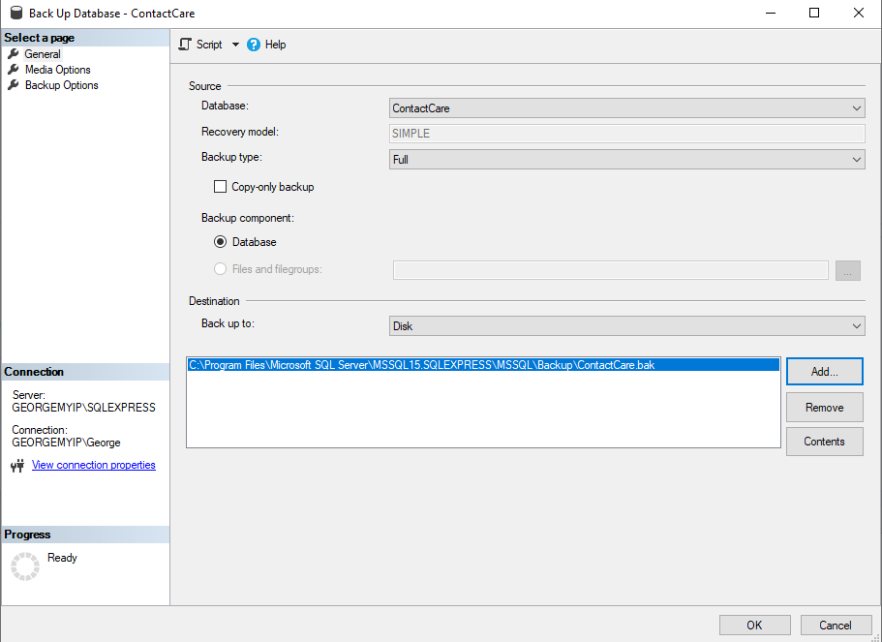

* Roles

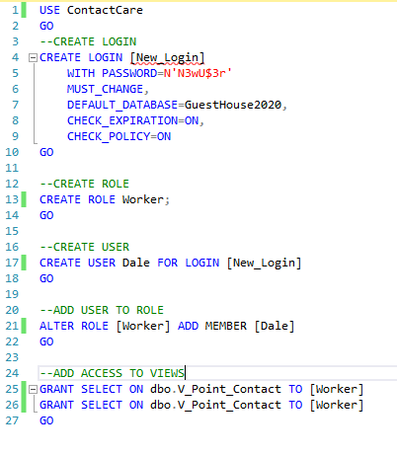

* Backup

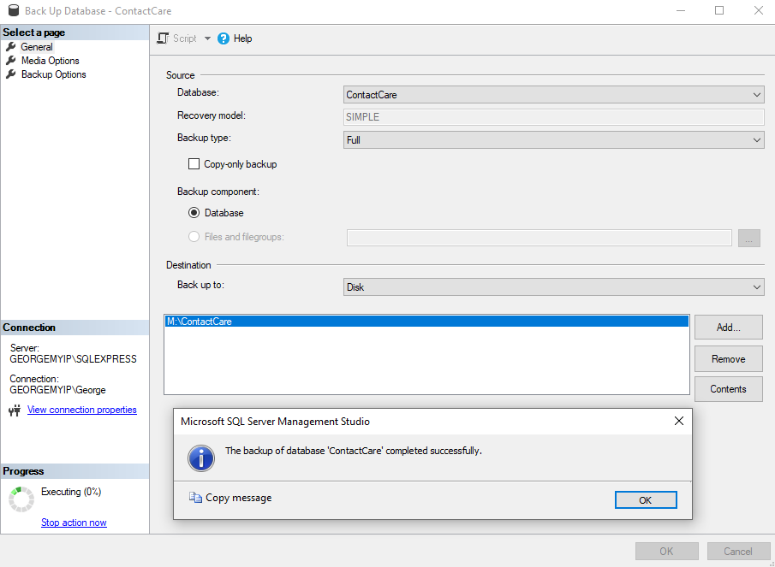

* Restore

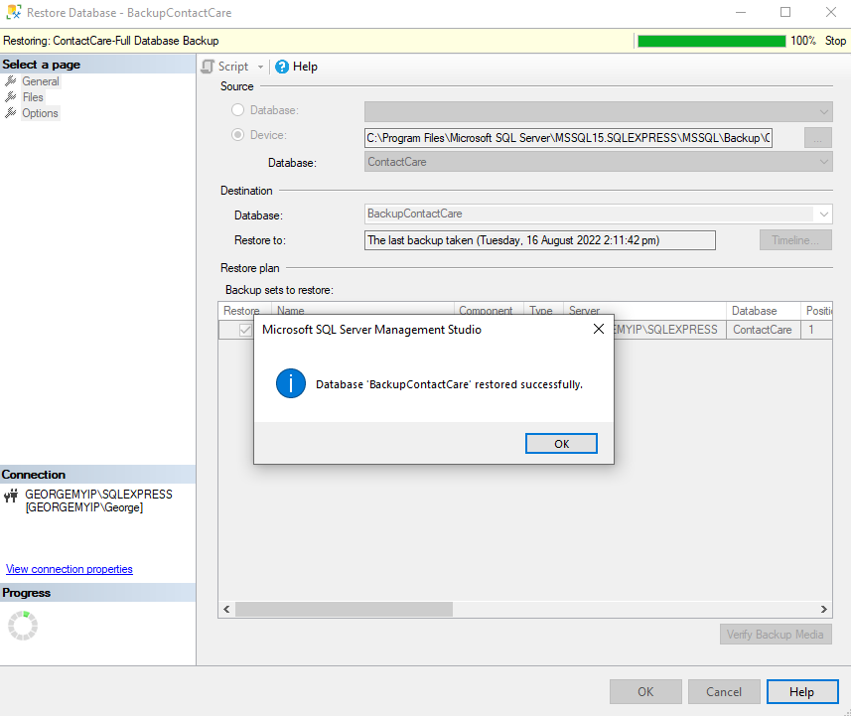

**GDPR:**

Data Minimisation: I made sure to limit the data taken for the contacts and carers to just their name and phone number. Only getting the users DOB and using it to work out information like age.

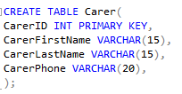

Transparency: Allowing a worker to show all the information they have on a patient as a view and query which would allow the patient to view their data and edit it if any information was wrong.

